Ayan Sarkar

UNIVERSITY OF DENVER

Structural equation modeling

**Path Analysis**

The conceptual diagram of the Path analysis is:-

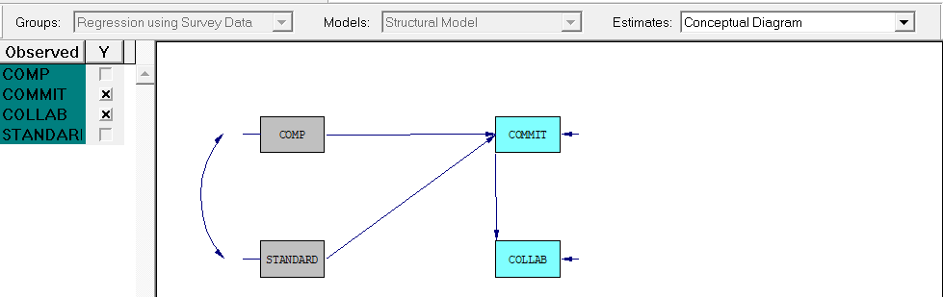

The model with the T-values are shown below:-

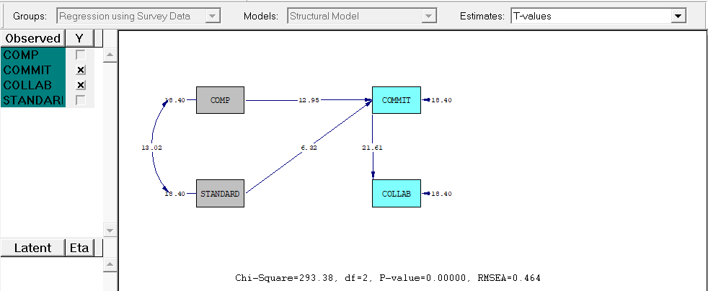

All the paths appear significant as per the T-values diagram.

Regression Equations for this model:

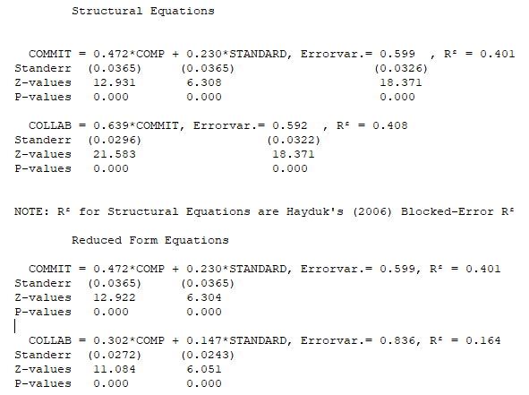

The T-values for the model with a test path from Competence to Collaboration:

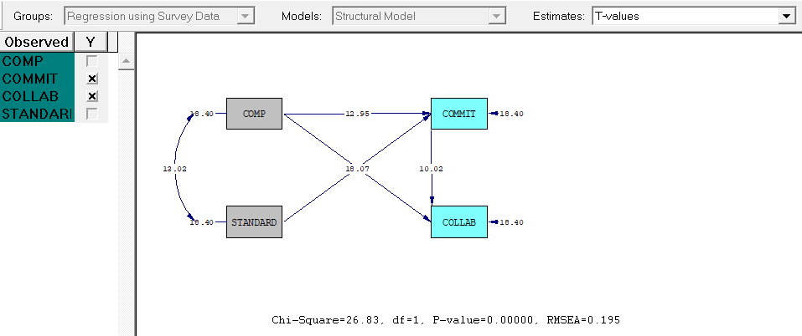

From this diagram, we can deduce that Commitment(COMMIT) is a partial mediator between Competence(COMP) and Collaboration.(COLLAB)

Regression Equations for this model:

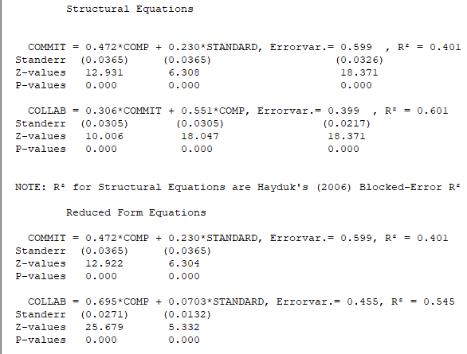

The T-values for the model with a test path from Standards to Collaboration:

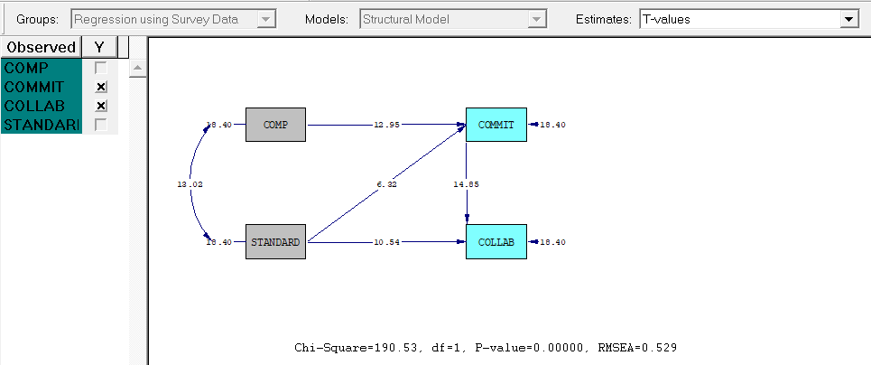

From this diagram, we can deduce that Commitment(COMMIT) is a partial mediator between Standards (STANDARD) and Collaboration.(COLLAB)

Regression Equations for this model:

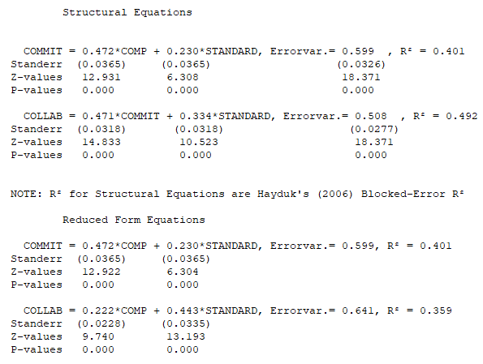

**Confirmatory Factor Analysis**

Observed variables: I1 I2 I3 I4 I5 I6 I7 I8 I9 I10 I11 I12 I13 I14

Latent variables: Competence Commitment Collaboration Standards

Relations:

I1 I2 I3 I4 = Competence

I5 I6 I7 = Commitment

I8 I9 I10 I11 = Collaboration

I12 I13 I14 = Standards

The T-Values for the Confirmatory Factor Analysis model are:

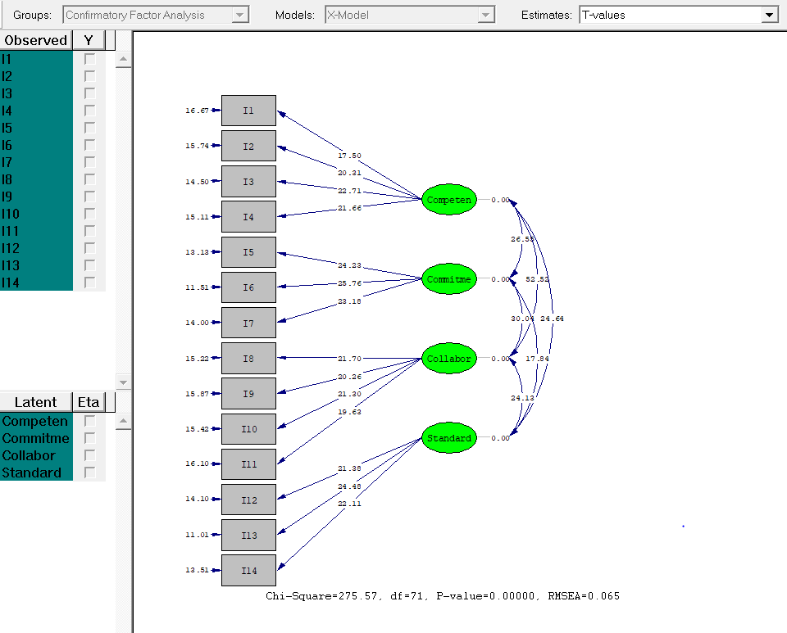

All the paths appear significant as per the T-values diagram.

Goodness-of-Fit Statistics:

Maximum Likelihood Ratio Chi-Square (C1) 275.566 (P = 0.0000)

Browne's (1984) ADF Chi-Square (C2_NT) 293.598 (P = 0.0000)

Root Mean Square Error of Approximation (RMSEA) 0.0652

90 Percent Confidence Interval for RMSEA (0.0572 ; 0.0735)

P-Value for Test of Close Fit (RMSEA < 0.05) 0.00106

Comparative Fit Index (CFI) 0.958

Goodness of Fit Index (GFI) 0.942

A good fit is indicated by the below thresholds of the Goodness of Fit parameters:-

RMSEA <0.08 acceptable fit: so, our model provides with an acceptable fit

GFI > 0.9 means satisfactory fit: so, our model provides a satisfactory fit

CFI > 0.9 means satisfactory fit: so, our model provides a satisfactory fit

All the p-values indicate that the Goodness of Fit Statistics are significant.

Regression Equations for the model:

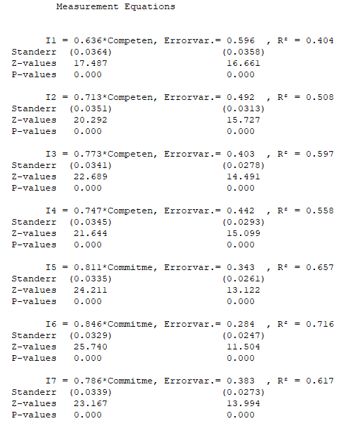

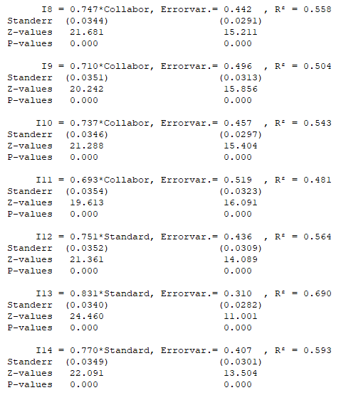

The regression equations give us the below conclusions:

* Competence is able to significantly explain 40.4% of variation in data in I1
* Competence is able to significantly explain 50.8% of variation in data in I2
* Competence is able to significantly explain 59.7% of variation in data in I3
* Competence is able to significantly explain 55.8% of variation in data in I4
* Commitment is able to significantly explain 65.7% of variation in data in I5
* Commitment is able to significantly explain 71.6% of variation in data in I6
* Commitment is able to significantly explain 61.7% of variation in data in I7
* Collaboration is able to significantly explain 55.8% of variation in data in I8
* Collaboration is able to significantly explain 50.4% of variation in data in I9
* Collaboration is able to significantly explain 54.3% of variation in data in I10
* Collaboration is able to significantly explain 48.1% of variation in data in I11
* Standard is able to significantly explain 56.4% of variation in data in I12
* Standard is able to significantly explain 69% of variation in data in I13
* Standard is able to significantly explain 59.3% of variation in data in I14

**Structured Equation Modeling**

Observed variables: I1 I2 I3 I4 I5 I6 I7 I8 I9 I10 I11 I12 I13 I14

Latent variables: Competence Commitment Collaboration Standards

Relations

I1 I2 I3 I4 = Competence

I5 I6 I7 = Commitment

I8 I9 I10 I11 = Collaboration

I12 I13 I14 = Standards

Collaboration = Commitment

Commitment = Competence Standards

The Conceptual Diagram for the Structured Equation modeling is:

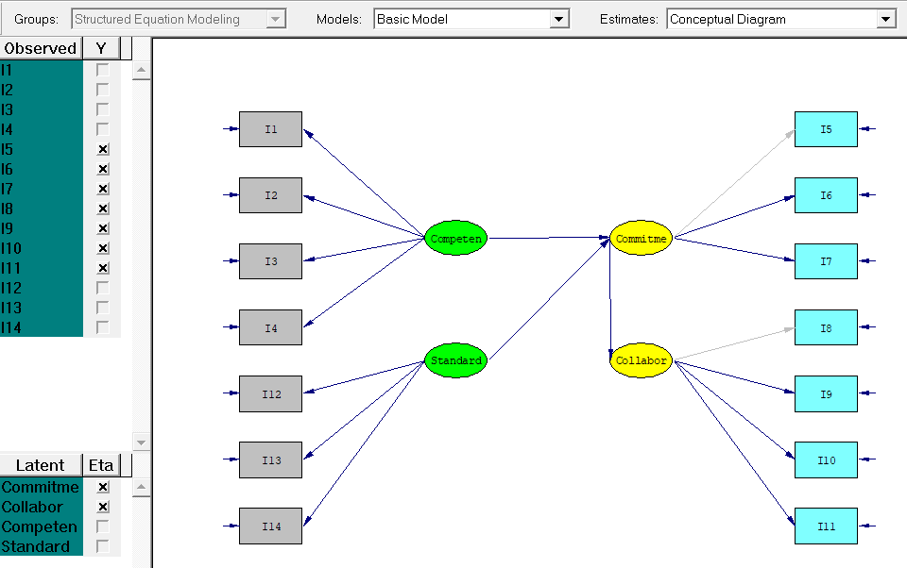

The T-Values for the Structed Equation modeling are:

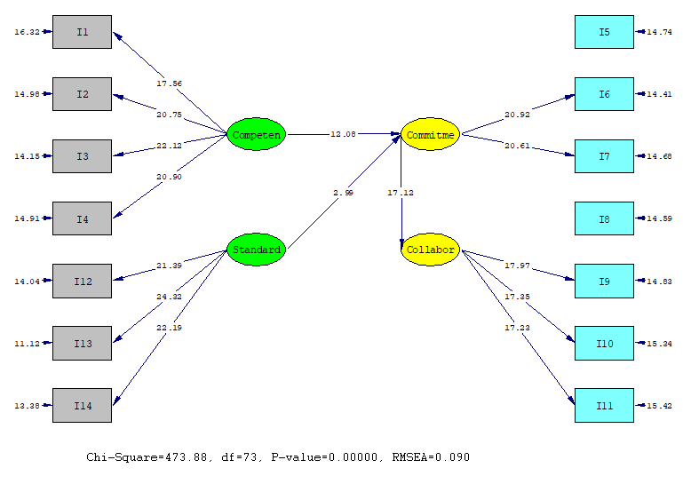

All the paths appear significant as per the T-values diagram.

Regression Equations for this model:

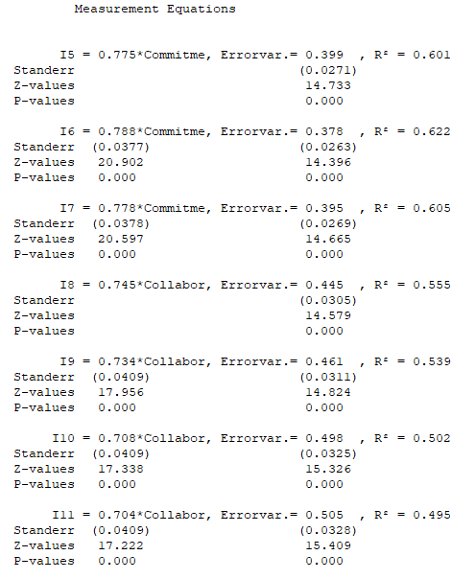

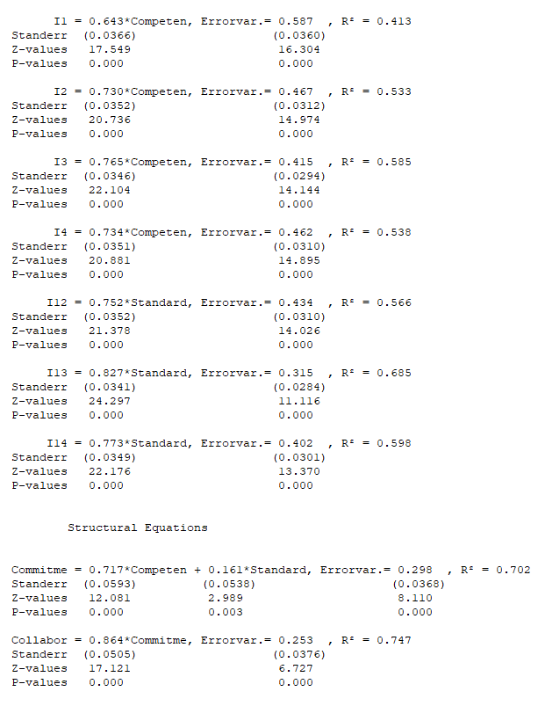

The T-values for the model with a test path from Standards to Collaboration:

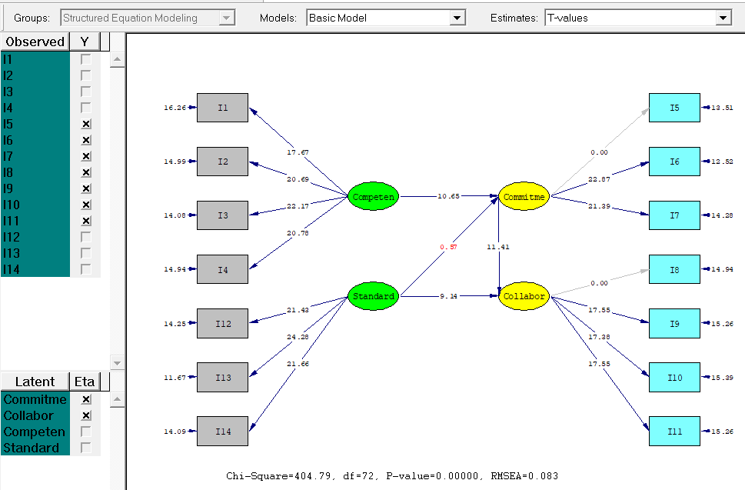

From this diagram, we can deduce that Commitment(COMMIT) is not a mediator between Standards(STANDARD) and Collaboration.(COLLAB)

Regression Equations for this model:

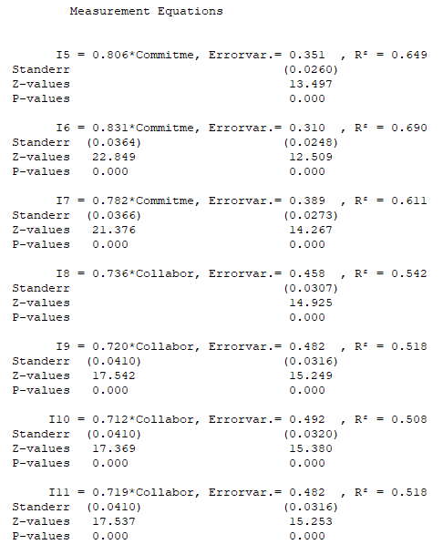

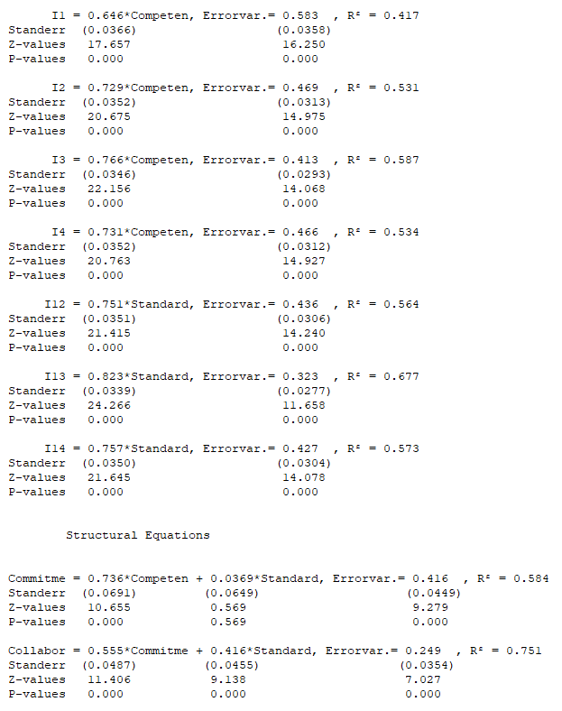

The T-values for the model with a test path from Competence to Collaboration:

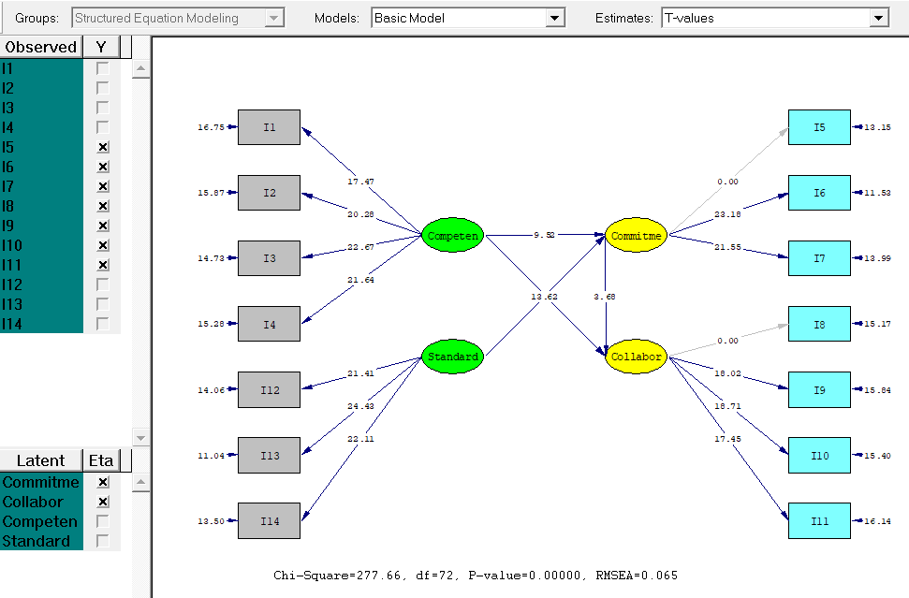

From this diagram, we can deduce that Commitment(COMMIT) is a partial mediator between Competence(COMPETENCE) and Collaboration.(COLLAB)

Regression Equations for this model:

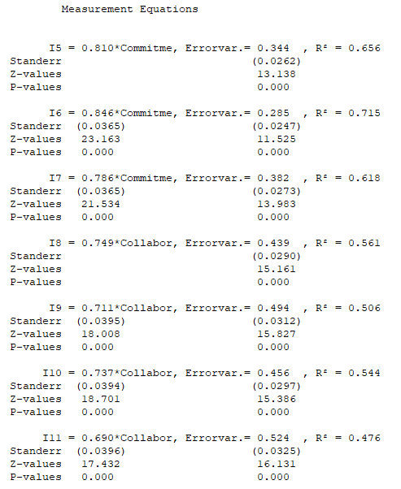

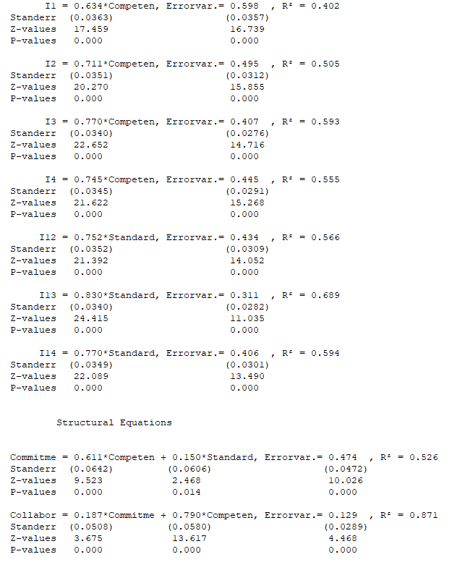

Differences between Path Analysis & Structured Equation Modeling Results:

